Jquery携带订单id跳转的2中方式 通过自定义属性 大写需要通过连字符进行转换

通过window.loacation.href跳转在后面拼接参数
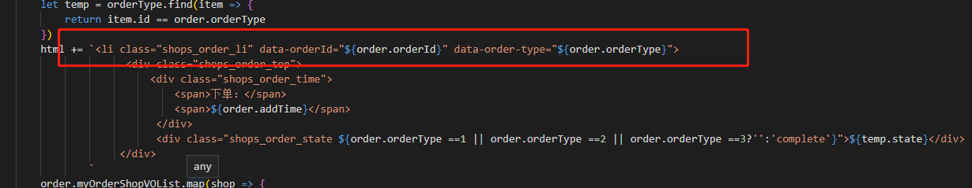

/**
* @Description: 点击订单跳转到订单详情页
* @Author: longhaiyan
* @Date: 2020-05-14 16:49:16
*/
$('body').on('click', '.shops_order_li', function (e) {
let orderid = e.currentTarget.dataset.orderid
let orderType = e.currentTarget.dataset.orderType
if (orderType == 0) {
return
}
location.href = 'realOrderDetail.html?orderId=' + orderid // 订单详情-待付款 待发货 待收货 已收货 已完成
})

通过a标签跳转
<a class="recommend_item" href="${url}?productId=${item.productId}">
<div class="recommend_item_pic">
<img src="${imgStateUrl + item.productImg}" alt="商品">
</div>
<div class="recommend_item_info">
<p>${item.productName}</p>
<div class="newprice">
<div class="newprice_l">￥<span> ${item.salePrice} </span>起</div>
<div class="newprice_r">返￥<span>${item.rebackMoney}</span></div>
</div>
<div class="oldprice">
<div class="oldprice_l">
<del style="display:${item.oldPrice?'inline':'none'}">￥${item.oldPrice}</del>
<span style="display:${item.discount?'inline':'none'}">${item.discount}折</span>

